Title: Developing and Implementing the SECAS Blueprint

Author: Mallory G. Martin

Affiliation: U.S. Fish and Wildlife Service

City, State: Raleigh, North Carolina

ABSTRACT: This presentation provides background on the Southeast Conservation Adaptation Strategy (SECAS) initiative, and specifically overviews development of the SECAS Blueprint. The SECAS Blueprint is a spatial representation of the collective conservation vision of multiple state and federal partners, and other entities participating in the SECAS initiative. Additional emphasis and explanation is provided on implementation of the SECAS Blueprint, priority Blueprint improvements, and expanding connections to non-traditional economic sectors and to adjoining regions outside the southeastern US.
What is driving the need for landscape-scale conservation in the Southeast? Simply put, the scope and scale of the challenges facing wildlife conservation are of a magnitude that no single agency or organization can address them alone. Moreover, these challenges are manifest across multiple jurisdictional boundaries, where individual agency responsibilities or authorities may not be relevant. These large-scale challenges include urbanization, energy development, climate impacts, and water stress. Looking at urbanization impact alone, we have the benefit of hindsight that can help us realize how development has affected the extent and quality of wildlife habitat in the Southeast since 1940. Looking forward to 2030, we have the benefit of technology and collaboration potential to help define a sustaining landscape for the future so that wildlife doesn’t just get what is left over from development.
The need for SECAS arises from these dramatic changes and unprecedented challenges on the landscape. However, SECAS also offers a clear opportunity for the future, based on coordinated action around a shared long-term vision involving diverse partners, resulting in a regional conservation future that can sustain wildlife in a coordinated, non-random fashion.
SECAS was initiated in fall 2011 by the directors of the state fish and wildlife agencies of the Southeastern Association of Fish and Wildlife Agencies (SEAFWA), who came together to address the question of how to define and achieve a landscape condition that sustains natural resources for the future in the southeast and Caribbean. Concurrently, the state directors asked the six Landscape Conservation Cooperatives (LCCs) active in the southeast to work with state agency contacts and other partners to provide the technical capacity and coordinating functions to advance a regional strategy for conservation. In spring 2012, those directors approached the federal Southeast Natural Resource Leaders Group (SENRLG) inviting their participation in the SECAS initiative. Thereby, SECAS was established with the following key characteristics:
- SECAS is a state-led initiative
- It is inclusive of the federal natural resource management agencies
- The technical capacity and coordination for planning and implementation come through LCCs
- Work is coordinated with Climate Science Centers, Joint Ventures, and Fish Habitat Partnerships
- The initiative incorporates a broad network of partners and sectors
Since 2011, this broad partnership established by the SECAS initiative has been focused on the following collective vision:
Through SECAS, diverse partners are working together to design and achieve a connected network of landscapes and seascapes that supports thriving fish and wildlife populations and improved quality of life for people across the southeastern United States and the Caribbean. Together, federal, state, non-profit and private organizations are coordinating their conservation actions and investments to focus on common goals.
To move forward toward realization of the collective vision it is necessary to have a good map. The SECAS Blueprint is that good map. It is a spatial representation of the collective vision for the future of natural resources in the southeast. It is also a living map that depicts the shared priorities for conservation and restoration on the landscape, not an acquisition boundary. The Blueprint integrates other blueprints and conservation planning tools and products of the LCCs covering the southeast, thereby identifying opportunities for cross-border collaboration to influence those cross-jurisdictional challenges affecting conservation in the southeast. The SECAS Blueprint is also intended to be updated regularly, contributing to a culture of continuous improvement (Figure 1).
The SECAS Blueprint stitches together the work of multiple LCCs into a map of shared conservation and restoration priorities across the southeast and Caribbean. The Blueprint combines multiple datasets, tools, and resources into one cohesive map that can be referenced and shared by regional planners, highway departments, developers, businesses, and conservation professionals alike. By providing regional context for local decisions, it will help organizations with different goals find common ground — opportunities to align their efforts to protect fish and wildlife habitat, improve quality of life for people, safeguard life and property, and develop strong economies. As the Blueprint informs the decisions affecting our communities, our livelihoods, and our natural and cultural heritage, it will shape a more sustainable future across the entire southeast region.
Literally thousands of people representing hundreds of diverse organizations have actively participated in developing the components of the SECAS Blueprint to date. It incorporates the best available information about the condition of key species and habitats, as well as future threats. Because the Blueprint is a living document, these mapped priorities will evolve over time, driven by improvements to the underlying science, our growing understanding of on-the-ground conditions, and input from new partners.
The Blueprint shows priority areas across a 15-state regional boundary and is being used to answer questions about:
- Connecting lands and waters across the 15-state southeast region
- Engaging other non-traditional sectors into conservation actions
- Incorporating future conditions into current decision making
- Integrating at-risk species distribution, habitat, and condition
- Acquiring new resources for regional conservation action
- Using existing conservation resources and capacity more efficiently and effectively
The “blue” areas of the SECAS Blueprint represent areas of high conservation value within the southeast region and were integrated across multiple LCCs through a consensus approach among the points of contact from the SEAFWA and SENRLG member groups. The blue areas are not intended to describe an acquisition boundary, nor are specific conservation outcomes identified for all blue areas, i.e., the Blueprint is non-prescriptive in regard to actions in any specific area. However, a suite of common conservation strategies and actions has been identified for portions of the Blueprint that can broadly apply to the high conservation value areas in the entire SECAS Blueprint (South Atlantic Landscape Conservation Cooperative 2017). Several examples of completed, on-going, and planned uses of the SECAS Blueprint are archived on-line at www.secassoutheast.org. From that website, access is provided to the Southeast Conservation Planning Atlas, a platform for data analysis and mapping where users can retrieve and perform analyses on spatial information related to their specific conservation goals.
Priority actions for updating the SECAS Blueprint include incorporating the most recent data sets, improving consistency across the full SECAS geography, and creating tools to help users filter the Blueprint for specific applications. Additional emphasis is being placed on improving the priority hubs and corridors layer, improving integration of at-risk species modeling to help refine prioritization, and integrating species of greatest conservation needs from individual state wildlife action plans.
Additional regional refinement is being considered for report-card type assessments of habitats and sub-regions, similar to the State of the South Atlantic publication that describes the ecological health score of ecosystems and habitats in the South Atlantic LCC geography (South Atlantic LCC 2015). Other, similar approaches have been undertaken for additional sub-regions of the SECAS geography, including the Tennessee River Basin and its report card for aquatic resource health. These sub-regional health assessments can serve as a baseline to help quantify the impacts of specific conservation actions and to identify specific areas needing improvement.
The SECAS Conservation Blueprint results from a broad collaboration of diverse conservation partners across the southeast. These partners are engaged in promoting awareness of the Blueprint, supporting a diversity of its uses and application, and improving the robustness and precision of the Blueprint’s constituent components. Elements of this Blueprint can be integrated with similar efforts at a larger national scale, such as the Nature’s Network initiative in the northeast and the Crucial Habitat Assessment Tool in the west, to define a seamless network of conservation priority and opportunity for the entire nation.
REFERENCE LIST
South Atlantic LCC 2015. State of the South Atlantic 2015: Understanding our Living Landscapes. http://StateOf.SouthAtlanticLCC.org Web. 4 Apr. 2018

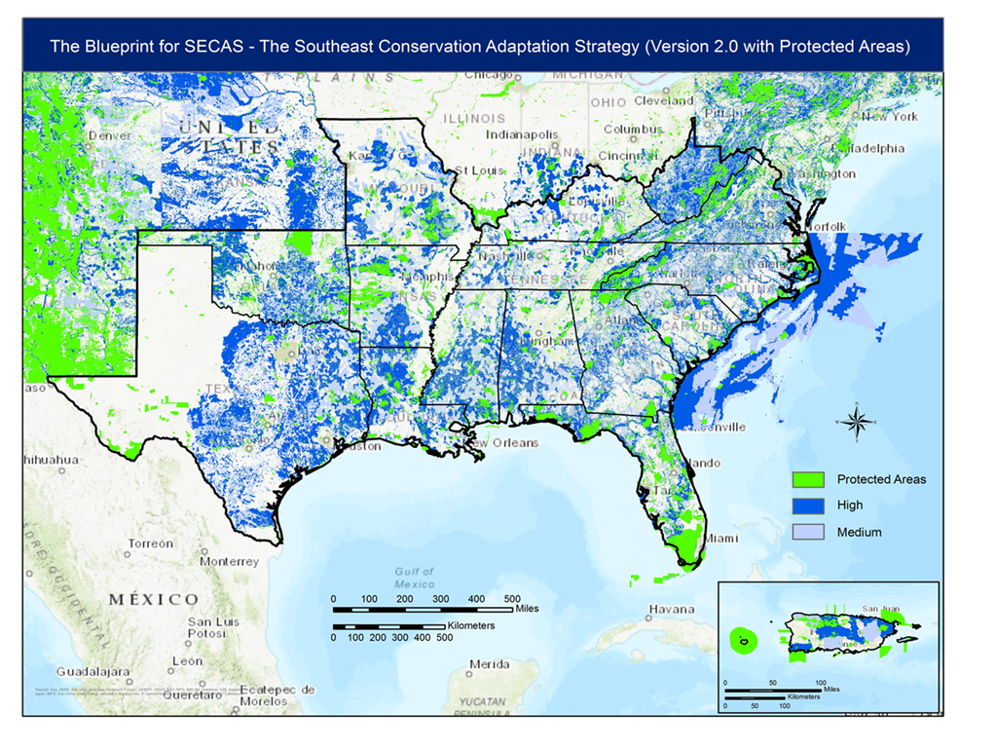
Figure 1. The SECAS Blueprint, version 2.0. http://secassoutheast.org/. Web. 4 Apr 2018.

